Simulation Scenario Development – Pneumothorax

- Scenario Overview
1a. Scenario Key Words
- Pneumothorax in the Adult Patient
1b. Scenario Name
- Pneumothorax in the Adult Patient
1c. Patient Care Improvement Opportunity
(Knowledge , Skill, Attitude, or Process Gap)
- VA nursing knowledge and skill training designed to improve Veteran patient care outcomes by the accurate assessment of Pneumothorax.
1d. Scenario Purpose
- A clinical simulation designed to assist Registered Nurses in the assessment of adult patients experiencing a Pneumothorax. This assists the nurse in recognizing and responding to changes in patient status.
1e. Setting for Scenario
- ICU Bed
1f. Modality
NOTE: In sections 1f through 1i, select items as needed.

☐Screen Based  ☒High Fidelity Simulator  ☐Standardized Patient | ☐Role Play  ☐Low-mid Fidelity Mannequin  ☐Task Trainer | ☐Hybrid (Blended Simulator)  ☐Other

1g. Confederates (Role Players)
☐Family Member(s)  ☐Physician(s)  ☐Resident(s)  ☐Respiratory Therapist | ☒Nurse(s)  ☐Paramedic/Emergency Medical Technician  ☐Other__________________________

1h. Scenario Support Staff
☒Scenario Faculty / Instructor
☒Simulator Technician
☐Confederates (from 5b)
☐Observers (i.e. other Learners, Co-Facilitators, etc.)

1i. Time Requirements
Set Up: | Scenario: | Debrief: | Reset/Breakdown:
10 minutes | 15 minutes | 10 minutes | 5 minutes

- Targeted Learners
- Registered Nurses.

- Learning Objectives / Knowledge, Skills, and Attitudes
General Content Objectives:
- Discussed the assessment of pulmonary function in the adult patient
- Describe the necessary steps to complete an assessment of the GI, endocrine, and renal systems
- Identify normal and abnormal findings related to cardiovascular assessment in the adult patient.
- Describe the stethoscope location for auscultation of the aortic, pulmonic, mitral, and tricuspid valves.
- Identify normal and abnormal cardiac sounds.
- Describe the physical assessment skills utilized in the assessment of patients with neurological dysfunction

Simulations and skills review will cover:
- Conduct a head to toe assessment of a patient with a neurological problem.
- Describe the FAST assessment.
- Describe the importance of time in the management of a patient experiencing symptoms consistent with stroke.
- Conduct a head-to-toe assessment of a patient with a respiratory problem.
- Describe signs of increased work of breathing.
- Identify normal and abnormal breath sounds.
- Describe the management of a patient experiencing an exacerbation of COPD.
- Identify symptoms consistent with a pneumothorax.
- Describe the management of a patient experiencing a pneumothorax.
- Identify how to set up, manage, and change a chest tube drainage system.

3a. Simulation Learning Objective 8:
- Identify symptoms consistent with a pneumothorax.
3a1. K/S/A
- K  - S  - A | Describe the signs and symptoms present with pneumothorax.  Demonstrate head-to-toe assessment of a patient experiencing symptoms consistent with pneumothorax.  Provides empathetic patient centered care during scenario.
3b. Learning Objective 9:
- Describe the management of a patient experiencing a pneumothorax.

3b1. K/S/A
- K  - S  - A |  | Describe measures that must be taken to evacuate air from the intra-pleural space.  Describe nursing responsibilities in assisting with the placement of a chest tube including set up, patient positioning, sedation and pain management.  Provides empathetic patient centered care during scenario.
3c. Learning Objective 10:
- Identify how to set up, manage, and change a chest tube drainage system.

3c1. K/S/A
- K  - S  - S  - A |  | Identify components of a chest tube drainage system.  Describe how to set up a chest tube drainage system.  If applicable, band connections of chest drainage system.  Provides empathetic patient centered care during scenario.

- Pre-Requisite Learning Activities
- Define activities required prior to completing scenario portion of the training (i.e. TMS module, additional courses of instruction).

- There are no prerequisites. This course is designed for nurses.

- Patient Information and Background
5a. General
Name: Sim, Bob
Gender: Male |  | DOB: July 9, 1947 |  | Ht: 5’8” |  |  |  | Wt: 225
5b. Vital Signs
BP: 125/87 | Temp: 99.8 |  | HR: 90 | RR: 28 |  | O2 Sat: 87% |  |  | Pain: 2
5c. History of Present Illness (Bullet format)
- A 68 year old man with a history of COPD, atherosclerosis, HTN, hyperlipidemia, and diabetes. The patient is here for generalized complaints of weakness and shortness of breath. Patient is flat in bed on room air.
5d. Physical Exam (Bullet format)
- General:  - HEENT: WNL  - Resp: Rhonchi. Left Pneumothorax  - Heart: WNL  - Abd: Soft, round, hyperactive BS |  |  |  | - GU: WNL  - Ext: WNL  - Skin: Intact  - Neuro:
5e. Review of Systems Subjective (Bullet format)
- CNS: WNL  - Cardiovascular:  - Pulmonary: No breath sounds on right  - Renal/Hepatic:  - Endocrine: |  |  |  | - GI:  - Heme/Coag:  - Musculoskeletal:  - Integument:  - Developmental HX:
5f. Past Medical History
- History of COPD, atherosclerosis, HTN, hyperlipidemia, and diabetes.
5g. Past Surgical History
- None
5h. Family History
- Cardiovascular disease for father and breast cancer for mother
5i. Social History
- Pack/day smoker x 25 years
5j. Vaccines
- Current
5k. Medication Allergies
- NKA
5l. Food/Other Allergies
- None
5m. Current Medications
Drug: |  |  |  |  | Dose: |  | Route: |  |  | Frequency:
Lipitor |  |  |  |  | 40mg |  | Oral |  |  | Once per day
Glucophage |  |  |  |  | 1000mg |  | Oral |  |  | BID
Lisinopril |  |  |  |  | 30mg |  | Oral |  |  | Once per day
Atrovent inhaler |  |  |  |  | One puff |  | inhaled |  |  | Every 6 hours

- Scenario Set Up
6a. Room Set Up
- Patient should be gown flat in bed. Patient is here for generalized complaints of weakness and shortness of breath.

NOTE: In sections 6b through 6d, delete or add items as needed.

6b. Equipment/Supplies Needed:
- Airway Equipment  ☒BVM  ☐OPA & NPA  ☒Non-Rebreather Mask  ☒Oxygen Source  ☒Suction  ☐Laryngoscopy Blade(s)  ☐Laryngoscopy Handles(s)  ☐Endotracheal Tube(s)  - Size(s): _______  ☐Stylet  ☐Syringe(s)  ☐Securing Device  ☐EtCO2 monitoring device  ☐Colorimetric end-tidal CO2 detector  ☐Supraglottic Device  - Type:_________  ☐Video Laryngoscope  ☐Bougie  ☐Difficult Airway Cart  - Vascular Access  ☐Peripheral IVs  ☐IOs  ☐IV and Tubing  ☐IV Fluids  - Catheter:_______ | - Monitoring Devices  ☒Cardiac Monitor  ☒Blood Pressure Cuff  ☒Pulse Oximeter  ☐Arterial Line  ☐CVP  ☒Temperature Probe  ☒Defibrillator  - Blood Components:  ☐PRBC  ☐Platelets  ☐FFP  ☐EKG Machine  - Medical Equipment  ☐Ventilator Machine  ☐BIPAP Machine  ☐IV Pumps  ☐Ultrasound Machine  ☐Bronchoscope  ☐Colonoscopy Scope  ☒Hospital Bed/Stretcher  - Medications (Name & Dose)  - ________________  - ________________  ☐Back Board  ☐NG Tube  ☐C-Collar  ☒Hotline (Phone)  Other:

Category | Item | Quantity
General | Hi-Fidelity Maniken | 1
 | Hospital Bed | 1
 |  | 1
Respiratory | Facemask available but not hooked up | 1
 | Ambu with mask at bedside | 1
 | Closed System Suction Equipment | 1
 | Pulse Oximeter | 1
 | Flow Meter | 1
 | Chest tube insertion tray | 1
 | Chest tube drainage system | 1
 | Banding gun with bands (20) | 1
 | Wall suction hook up for chest tube drainage | 1
 | Petroleum gauze | 1
 | 4X4 gauze--tape | 1
 | Stethoscope | 1
 | Alcohol Wipes to clean stethoscope | Several
Cardiac | Patient hooked up to ECG monitor and pulse oximeter | 1
Medications | IV Midazolam | 1
 | IV Morphine | 1
 | Atrovent inhaler | 1
 | Albuterol neb available | 1

6c. Scenario Supplements
☒Patient ID Band/Allergy Band
☒Patient Chart
- Lab Reports
☒CBC
☒Chemistry
☒Cardiac Profile
☒Coagulation Profile
☒Type and Cross
☒ABG
☐Forms (i.e. DNR):______________________
☒X-Ray: _______showing right pneumothorax and tension pneumothorax (instructor brings)
☐EKG: _______________________________
☐Moulage: ____________________________
☐Other: ______________________________
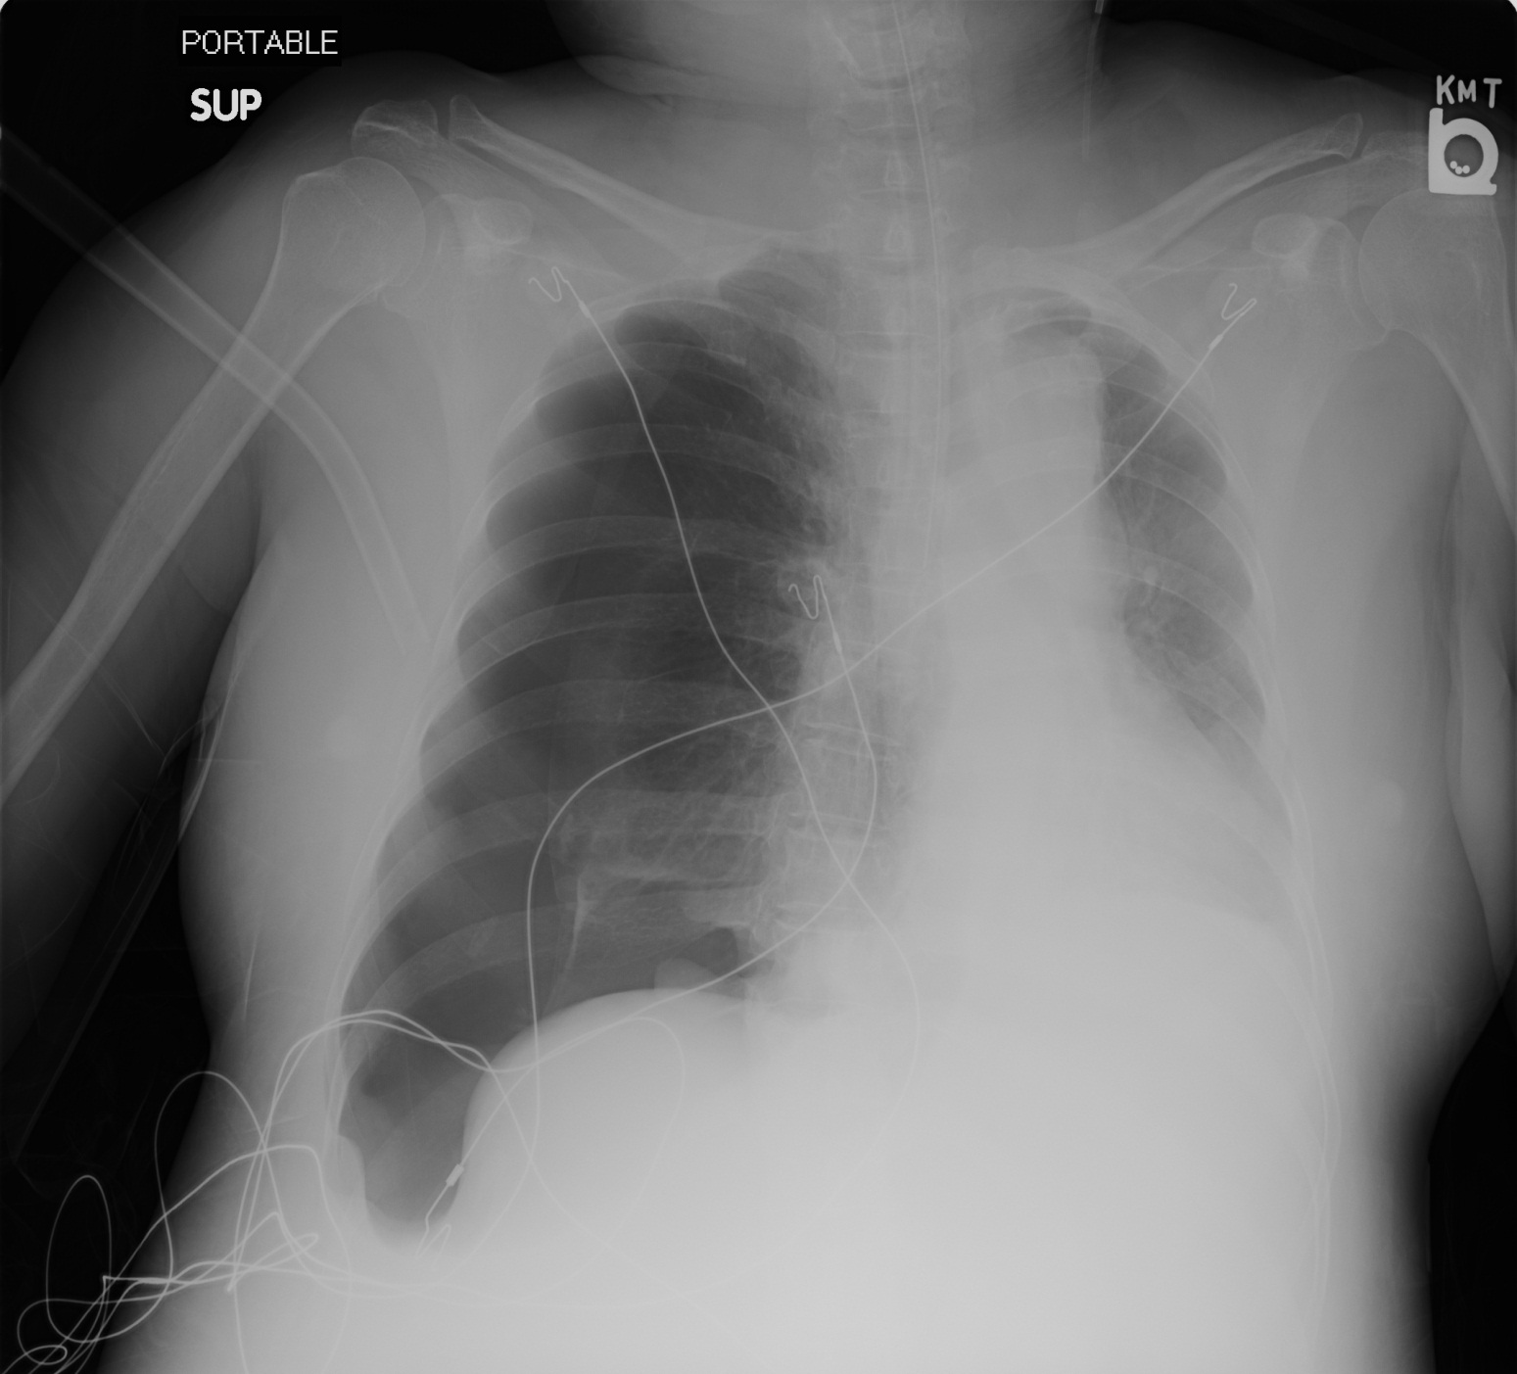

6d. Simulator Preparation
- Clothes required: __Patient gown__________
- Intubated: ______No____________________
- Bandages applies:
☐Head: _________________________
☐Chest: _________________________
☐Extremities: ____________________
☐ABD: _________________________
- Bleeding
- IV Fluid: _____________________________
- Initial SimMan 3G settings:

CV: 90; with Systolic murmur. Second Degree Heart Block Type I
Chest/Pulm: Left lung collapsed (pneumothorax)
VS: BP HR RR SpO2 T : VS: 125/87, HR-90, RR-28, T:99.8, O2 sats 87% (baseline)
Neuro: WNL. Weak pulses in extremities.
Skin: Intact
Eyes: WNL
Abd: Soft, round, Hyperactive BS
Labs WNL, ex. Low Mg and A1C=5.6

Other assessments:

Nursing Actions:

Patient’s initial exam: Head to Toe Assessment: It is change of shift and you are to perform your scheduled assessment. The patient is here for generalized complaints of weakness and SOB.

Patient complains of shortness of breath and speaks in short sentences and sounds short of breath. Also complains of chest pain left side of chest that occurs with inspiration.

Intervention Considerations
- HOB elevate
- O2 administration
- Listen to Lung Sounds/Heart Sounds
- Pain Assessment: (Morphine)
- Chest Tube Insertion: Set up pleur-evac
- CXR
- ABG/VBG
- Labs: HCG/HCT, D-Dimer, BNP, etc.
- DVT prophylaxis
- IVF infusion for low B/P

If group does not pick up on pneumothorax:
Gradually drop O2 sats to high-70’s and BP to 92/70 with increasing HR to 140.
If they call the MD, they will be instructed to get a CXR. MD arrives and shows CXR showing pneumothorax; tells nurses to prepare for CT insertion.

Question:

Would you call the MD or Rapid Response Team or handle the issues yourself?

You need to get assistance. Who you call probably depends on where you work. ICU staff may call the MD but others should probably call both.

Have them “call” the MD and give information. Ask them about breath sounds and chest symmetry if they have missed the pneumothorax diagnosis—ask them to get a CXR. When MD/RRT arrives they diagnose pneumothorax and nurse needs to prepare for CT insertion (pain meds and sedation, get tray for CT insertion and a pleur-evac. Review how to set up pleur-evac:

- Both VA and HCMC have the water for the seal behind the pleur-evac—add to water seal chamber.
- For adjustment of the suction at -20 cm H20, knob in front at HCMC and wheel on side for VA. Rest is pretty much the same on the pleur-evacs for both hospitals.
- Banding connections is MD preference at HCMC; band on MICU; no bands or just use tape on STNU. Have each person practice banding in case they have to do it.
- Show how to change the pleur-evac: slide clamp and disconnect/reconnect new one, unclamp.
- Discuss CT insertion: MD makes an incision, tunnels with gloved finger, uses trocar (or removes trocar and uses forceps) to push through the intercostal muscle into the interpleural space and then secure the tube with a suture. It is painful. That is why we give pain meds/sedate.
- MD may choose to “needle” the chest to remove the air with a syringe if the patient is decompensating and the set-up is not ready. Not all pneumo decompressions require a chest tube or needle evacuation. Some resolve on their own. MD will assess and decide.
- Nursing responsibilities are to prepare the patient (i.e., tell them what is happening, have consent obtained, give pain meds and/or sedation, and position them as instructed). Also need to have the pleur-evac ready to attach to CT. Get CT insertion tray for MD. After, secure connections as per your policy and apply an occlusive dressing (petroleum dressing topped with a 4X4).

Debriefing questions:

What would happen if we did not pick up on the pneumothorax?
It could progress into a tension pneumothorax with mediastinal shift, tracheal deviation, and obstruction of venous return to the heart. This can lead to circulatory instability and arrest.
For VETS HOMES:
What can we do to stabilize the patient while emergency transportation is being arranged?
What should you do if the connections come apart or the system integrity is compromised?
Attach a new pleur-evac. Show how to do this. Some sources recommend placing the end of the tube in a cup of sterile water as a water seal until a new system can be set up. It is not a good idea to clamp the chest tube for longer than a minute as a tension pneumothorax can develop.
How do you get a sample of the CT drainage?
Show sample port.
Can I “strip” the CT if I suspect a clot? No
Can I disconnect the chest tube to change the patient’s clothing? No, it is a sterile, closed system.
If I am going on a road trip, can I put the pleur-evac on top of the bed to transport? The pleur-evac should remain below the level of the chest—use hooks to attach it to the bed frame.

